**Physics Name____________________**

**Friction Problems Date _____________________  
  
Directions –** For each of the following problems begin by drawing a force diagram. Use this diagram, along with the   
 equations for friction to solve for the desired quantities.

1. An object weighing 35 N is pulled horizontally at constant speed. If the coefficient of kinetic friction (µ) is 0.2, what is the frictional force exerted on this object?

1. The force of friction for a 7.5-kg object being pushed horizontally at a constant speed is found to be 25 N. What is the coefficient of kinetic friction (µ)?

1. A 30-kg wooden box is resting on a carpeted surface. If the coefficient of static friction is 0.75, what is the force needed to start the box moving?

1. An applied force of 21 N accelerates a 9.0-kg wagon at 2.0 m/s2 along the sidewalk.  
    a) How large is the frictional force?

b) What is the coefficient of friction?

1. A sled of mass of 50.0 kg is pulled along a flat, snow-covered ground. The static friction coefficient is 0.30. The coefficient of kinetic friction is 0.10.  
    a) What does the sled weigh?

b) What force is needed to start the sled moving?  
  
  
  
  
  
  
  
  
 c) What force is needed to keep the sled moving at a constant velocity?

d) Once moving, what must the applied force on the sled be to accelerate it at 3.0 m/s2?

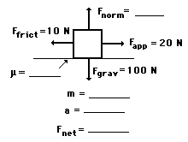

1. 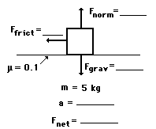 An applied force of 20 N is used to accelerate an object to the right across a frictional surface. The object encounters 10 N of friction. Use the diagram to determine the normal force, the net force, the coefficient of friction ("mu") between the object and the surface, the mass, and the acceleration of the object. (Neglect air resistance.)
2. A 5-kg object is sliding to the right and encountering a friction force which slows it down. The coefficient of friction ("mu") between the object and the surface is 0.1. Determine the force of gravity, the normal force, the force of friction, the net force, and the acceleration. (Neglect air resistance.)
3. Joey applies a 4.25-N rightward force to a 0.765-kg book to accelerate it across a table top. The coefficient of friction between the book and the tabletop is 0.410. Determine the acceleration of the book. Remember to draw your own force diagram similar to the ones above.